CSA1411-COMPILER DESIGN

LAB EXPERIMENTS

NAME:- R KALAI AMUDHAN

REG NO:- 192511292

EXPERIMENT – 1:
- AIM :- The lexical analyzer should ignore redundant spaces, tabs, and new lines. It should also ignore comments. Although the syntax specification states that identifiers can be arbitrarily long, you may restrict the length to some reasonable value. Develop a lexical Analyzer to identify identifiers, constants, and operators using the C program.
CODE:-
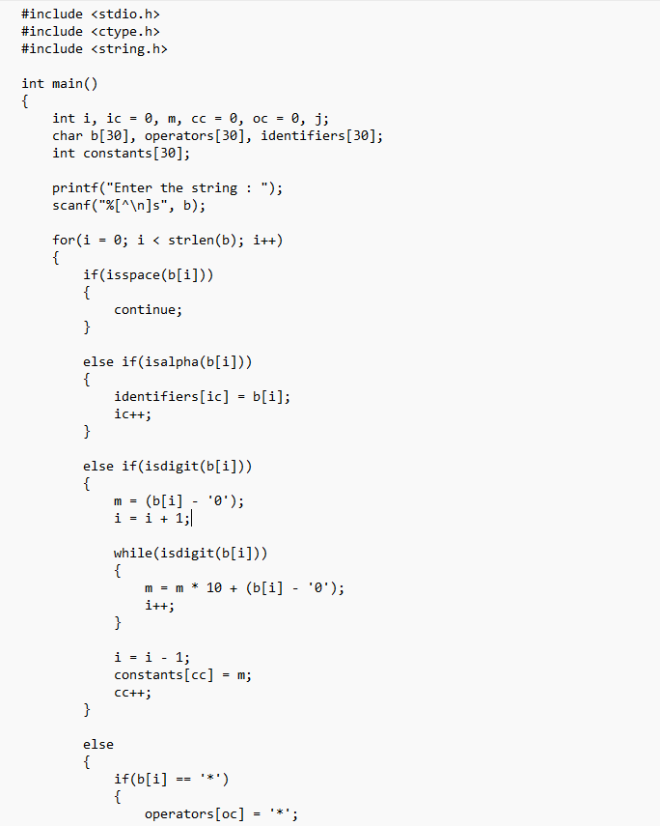
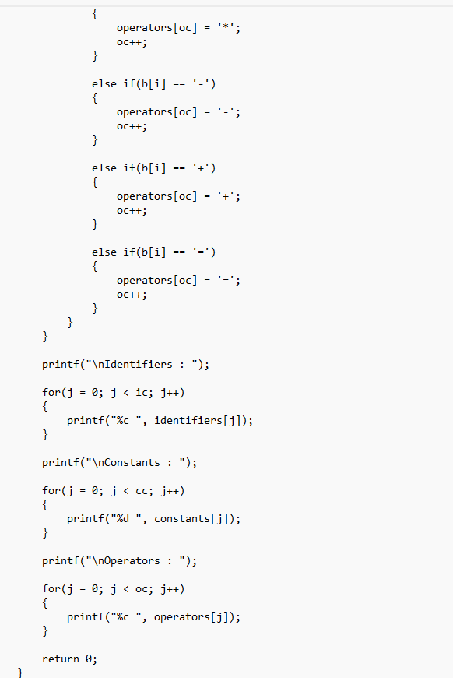
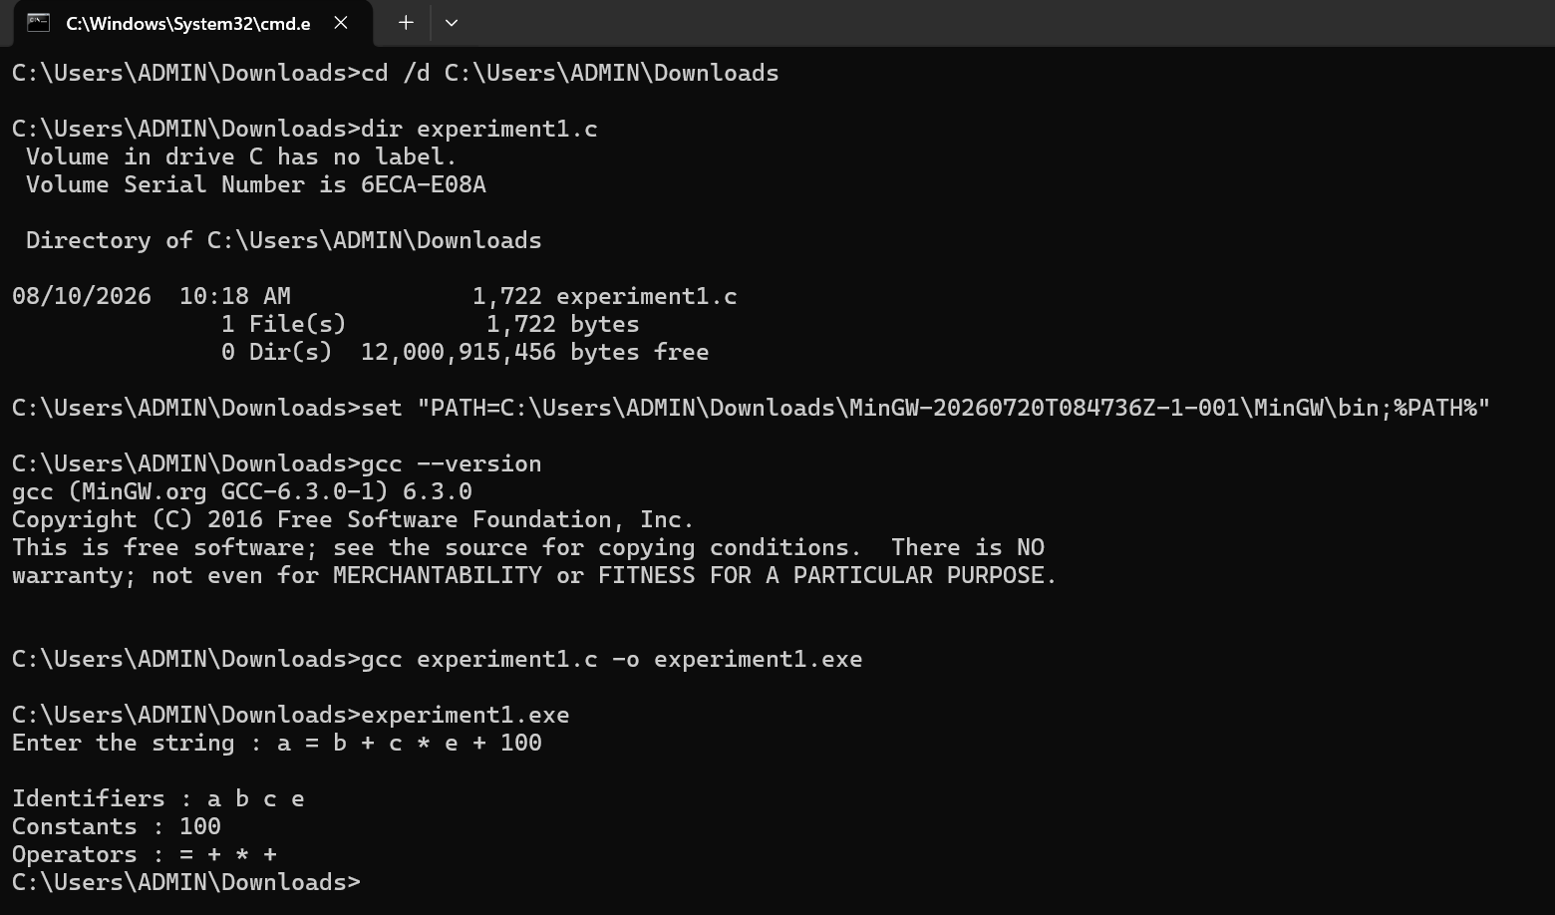
OUTPUT:-

